### **Antique Gold Decorative Frame Convex Mirror**

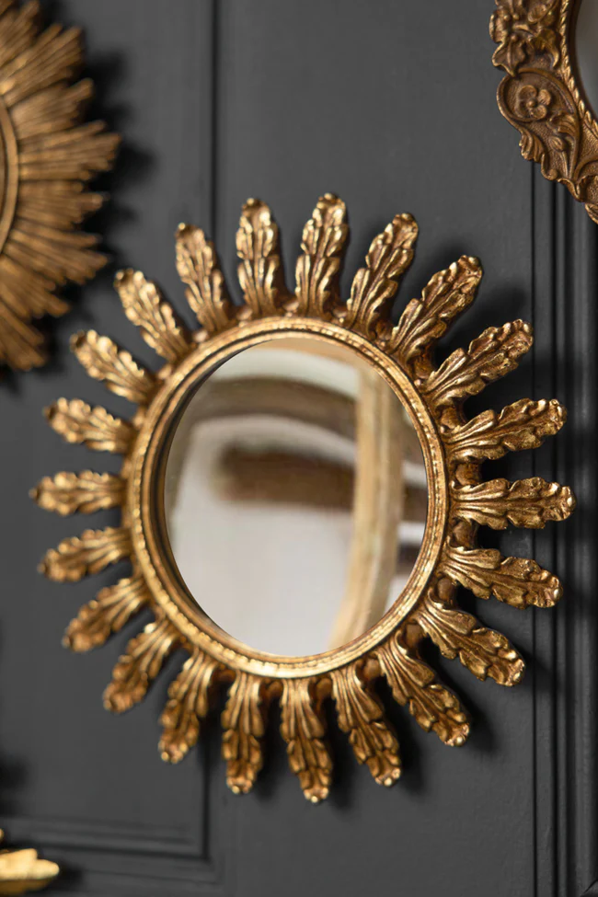The Antique Gold Decorative Frame Convex Mirror is a stunning blend of elegance and vintage charm. With its beautifully detailed antique gold frame, it brings an air of sophistication to any room. The convex shape of the mirror offers a unique visual effect, reflecting light in a way that enlarges and enhances the space around it. Perfect for traditional or classical interior styles, this mirror not only serves as a functional piece but also acts as a striking decorative element, adding warmth and character to your living space or hallway. Its timeless design and quality craftsmanship make it a perfect addition to any home that appreciates both style and history.